Docker-3
- Create a image from running container.
Started container and checked and container is running successfully.
docker start nginx-container
docker ps
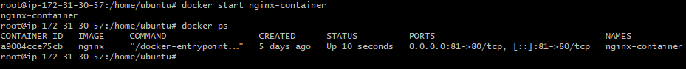
Login into the container
docker exec -it nginx-container bash
cd /usr/share/nginx/html
ls
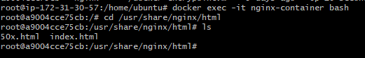
Modify the web page
echo "<h1>Charitha Docker Commit Demo</h1>" > index.html
cat index.html
exit
curl ifconfig.me
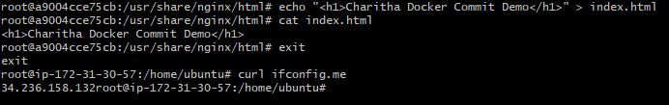
Verified in browser
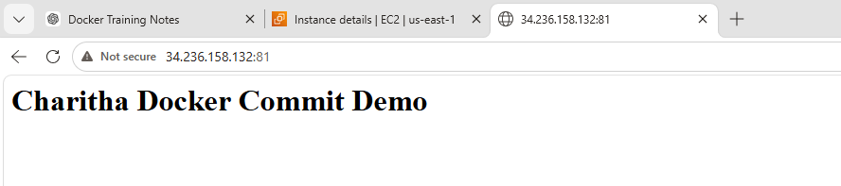
Create Image from Running Container
docker commit nginx-container nginx-custom:v2
docker images
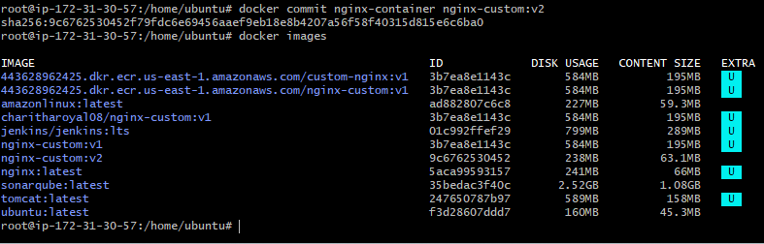
docker run -itd \
--name nginx-custom-v2 \
-p 8080:80 \
nginx-custom:v2
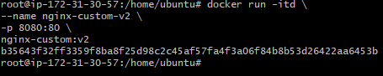
docker ps
Test in new page
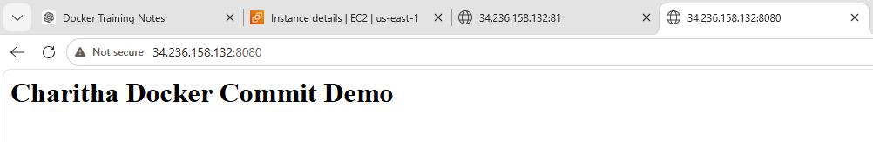
- Copy image from local machine to docker server and load the image.
Check Available Images on Local Machine
docker images 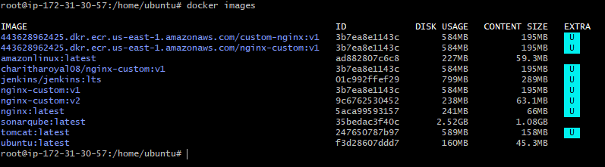
Save Image as TAR File
docker save -o nginx-custom-v2.tar nginx-custom:v2
ls -lh nginx-custom-v2.tar
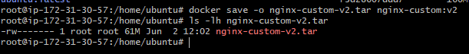
Remove Existing Container Using Image
docker ps -a
docker rm -f nginx-custom-v2
docker rmi nginx-custom:v2
docker images
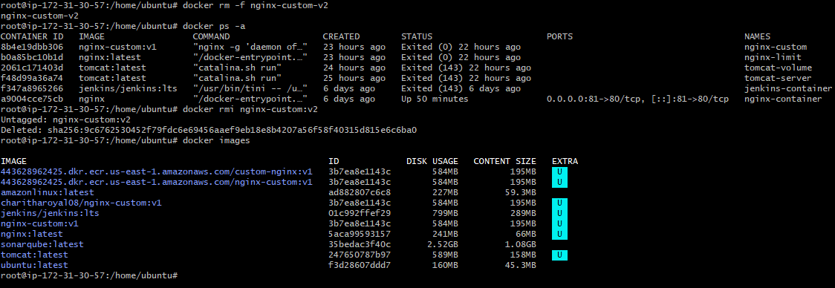
Load the image back from TAR file
docker load -i nginx-custom-v2.tar
docker images
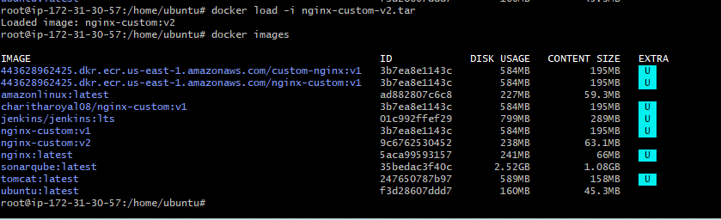
Run a new container
docker run -itd \
--name nginx-loaded \
-p 8081:80 \
nginx-custom:v2
docker ps
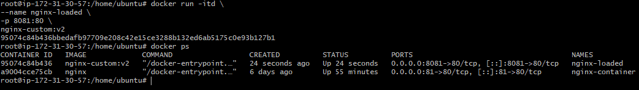
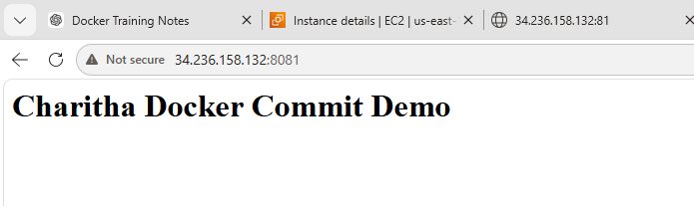
- Create Docker image using alpine and customize with tomcat.
Pull Alpine Image
docker pull alpine:latest
docker images
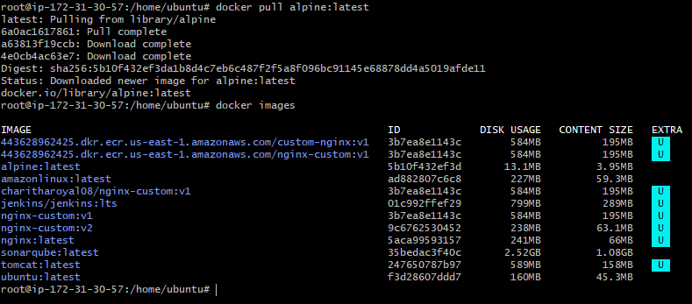
Create Dockerfile
mkdir tomcat-alpine
cd tomcat-alpine
vi Dockerfile
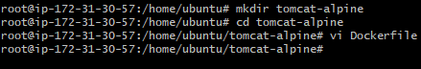
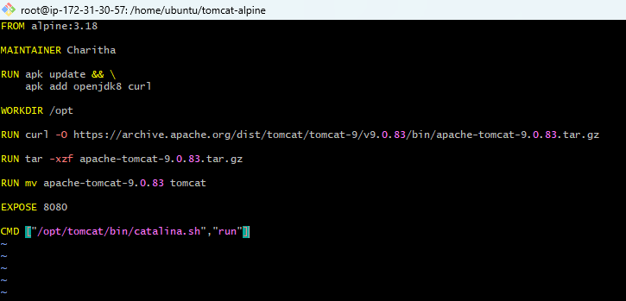
Build Image
docker build -t tomcat-alpine:v1 .
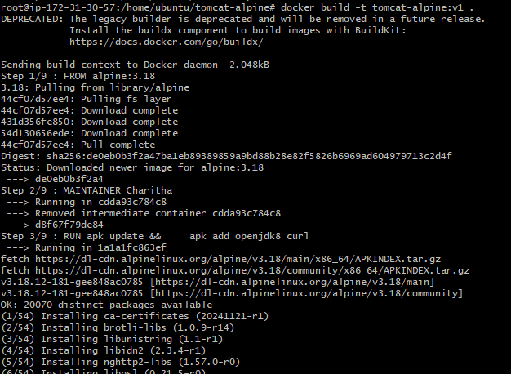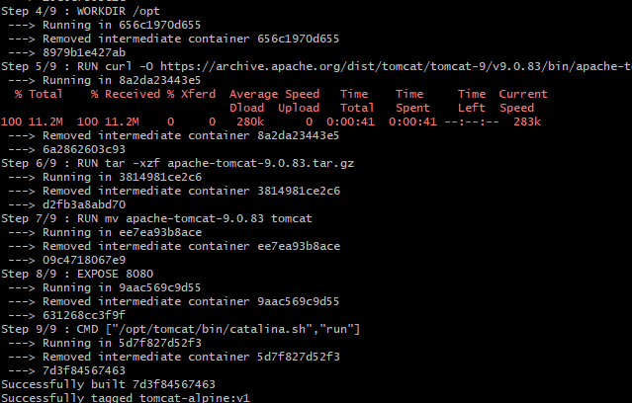
Verify Image
docker images
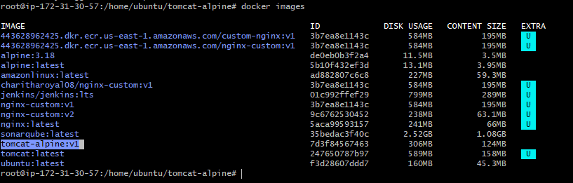
Run Container
docker run -itd \
--name tomcat-alpine-container \
-p 8080:8080 \
tomcat-alpine:v1
docker ps
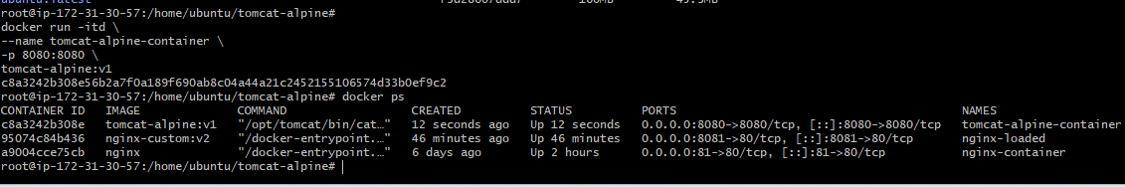
Access Application successfully
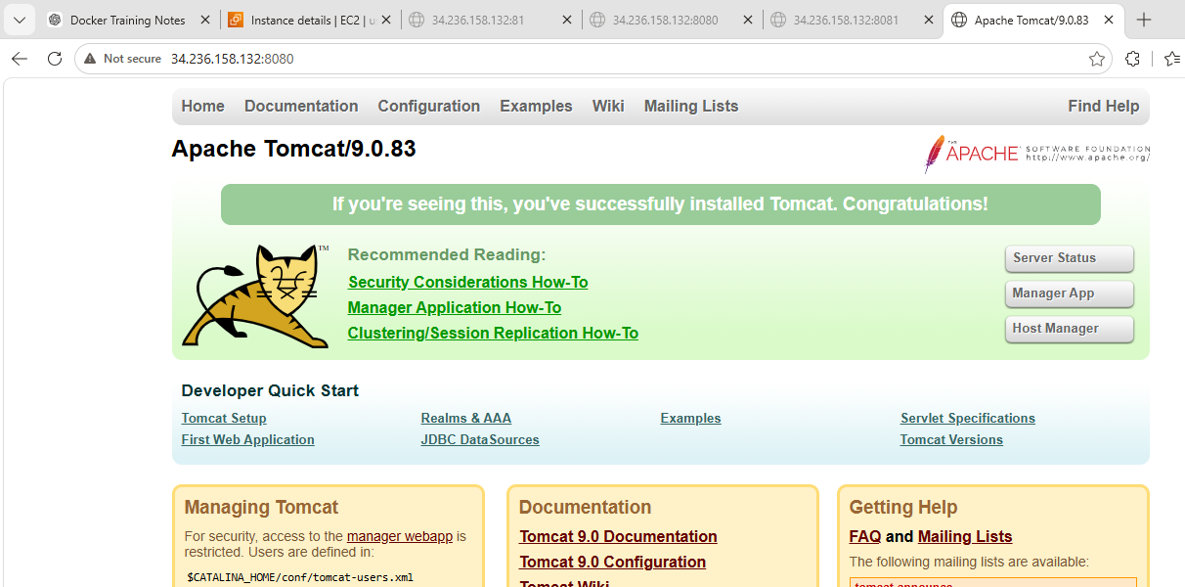

- Create single stage and multi stage docker file using this source code:https://github.com/betawins/multi-stage-example.git
Create Single Stage and Multi Stage Dockerfile Using Source Code
git clone https://github.com/betawins/multi-stage-example.git
cd multi-stage-example
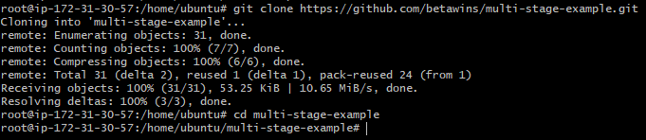
Single Stage Dockerfile
Create Dockerfile
vi Dockerfile
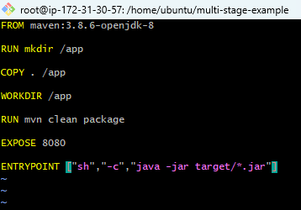
Build Image
docker build -t single-stage:v2 .
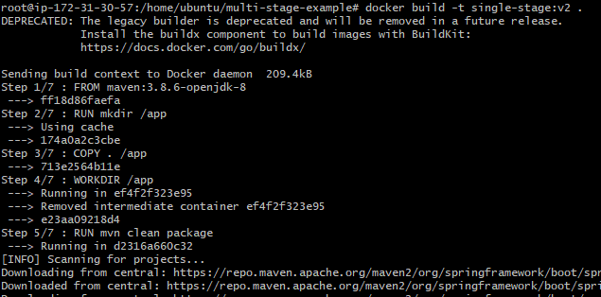
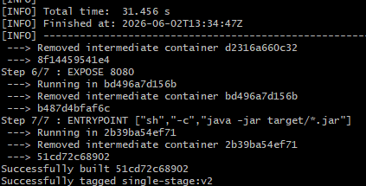
docker run -itd \
--name single-stage-container \
-p 8082:8080 \
single-stage:v2
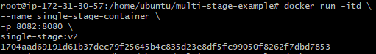
docker ps
docker logs single-stage-container
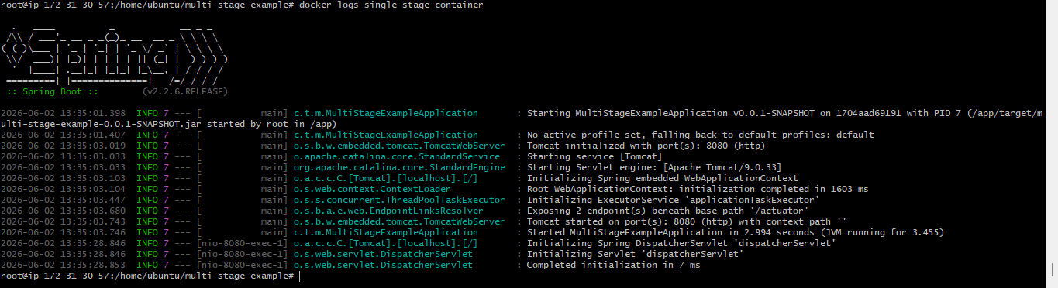
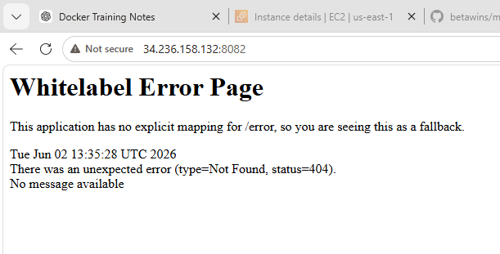
Multi Stage Dockerfile
Create a new file
vi Dockerfile-multi
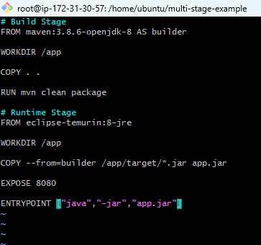
docker build -f Dockerfile-multi -t multi-stage:v2 .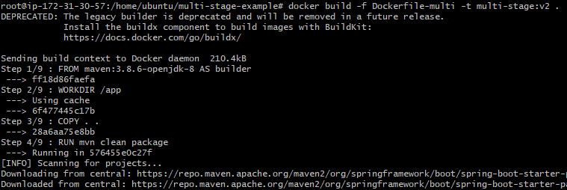
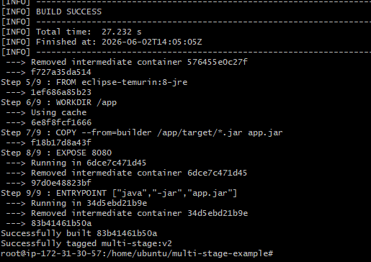
docker run -itd \
--name multi-stage-container \
-p 8083:8080 \
multi-stage:v2
docker ps
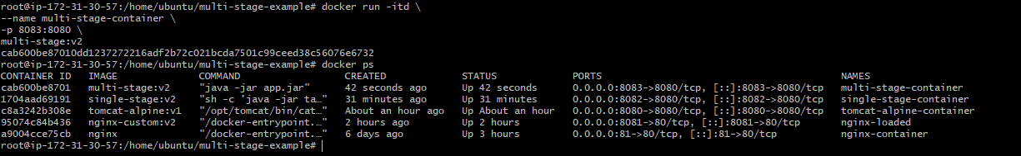
Using a Multi-Stage Dockerfile, I reduced the image size from 965 MB to 424 MB
docker images | grep stage
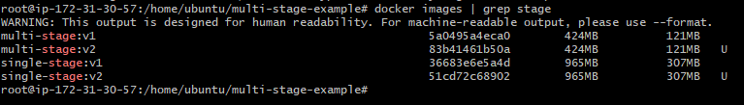

- Install docker compose and execute sample application.
apt update
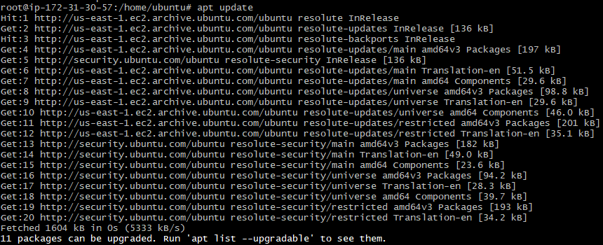
apt install docker-compose-v2 -y
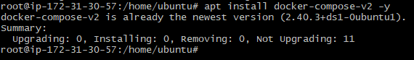
docker compose version
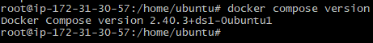
Install Docker Compose and Execute Sample Application
mkdir compose-demo
cd compose-demo
Create the compose file
vi docker-compose.yml
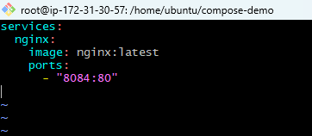
Run the application
docker compose up -d
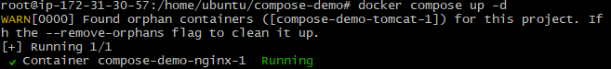
docker compose ps
Verified in browser
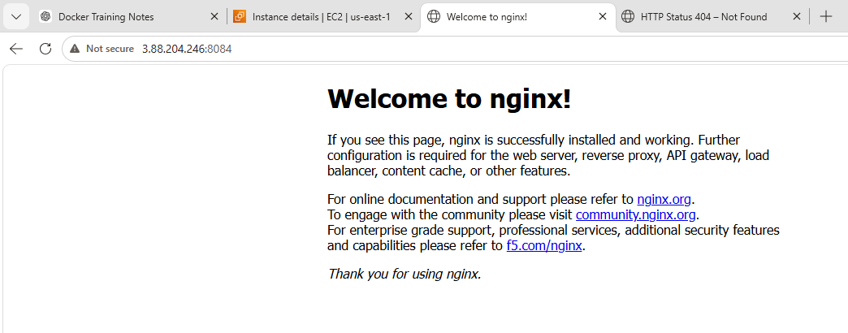
- Implement solution to scan images when pushed to docker registry.
Login to Docker Hub

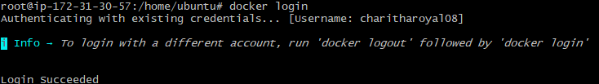docker tag nginx-custom:v2 charitharoyal08/nginx-custom:v2
docker images | grep nginx-custom
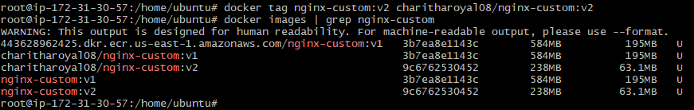
docker push charitharoyal08/nginx-custom:v2
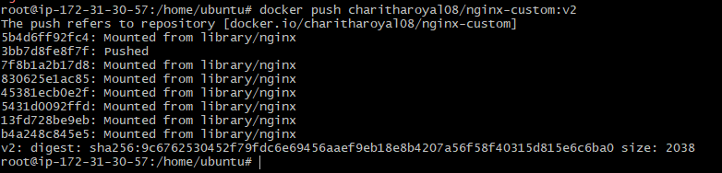
Login to Docker Hub.
Open repository nginx-custom.
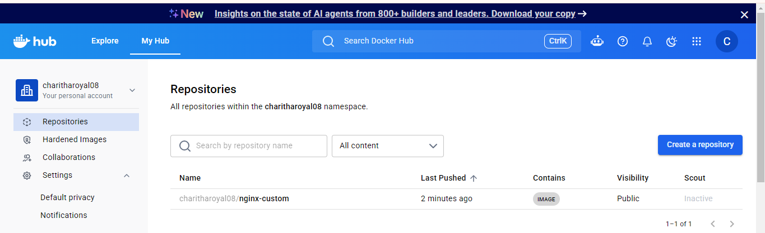

Here the docker scout is inactive lets activate it
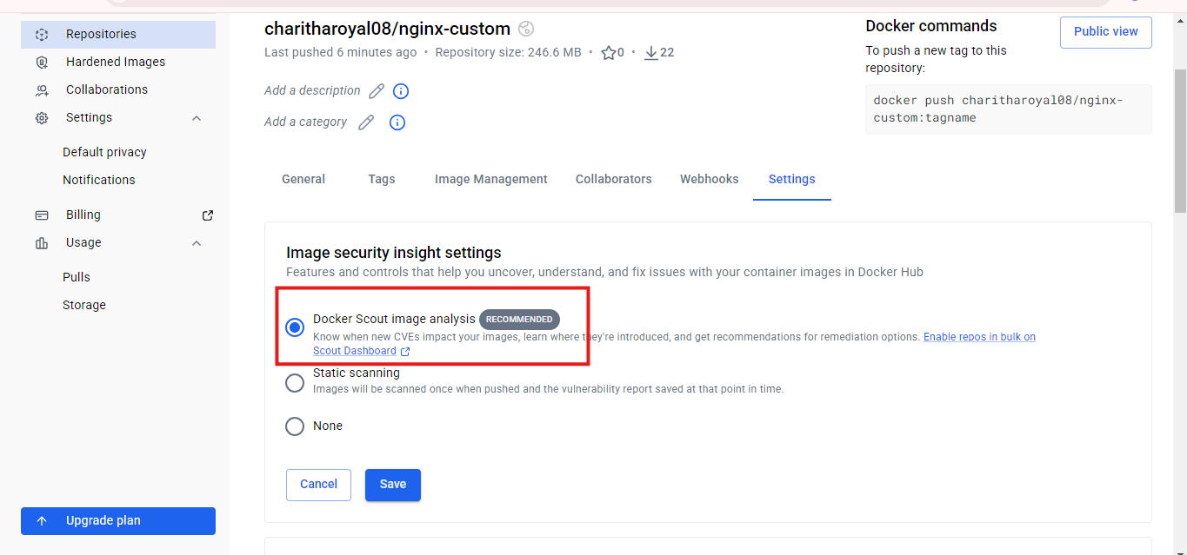
So the docker scout is now activated
Docker Scout automatically analyses every newly pushed image and generates vulnerability reports, helping identify security issues before deployment.
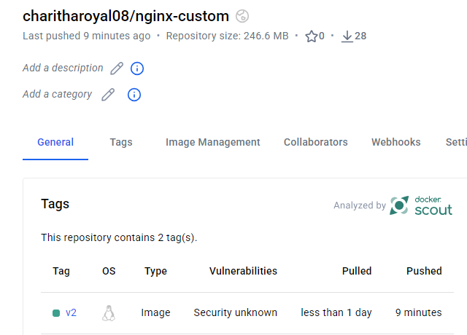
- Implement solution to scan images when pushed to AWS ECR.
Open AWS ECR
Go to features and settings
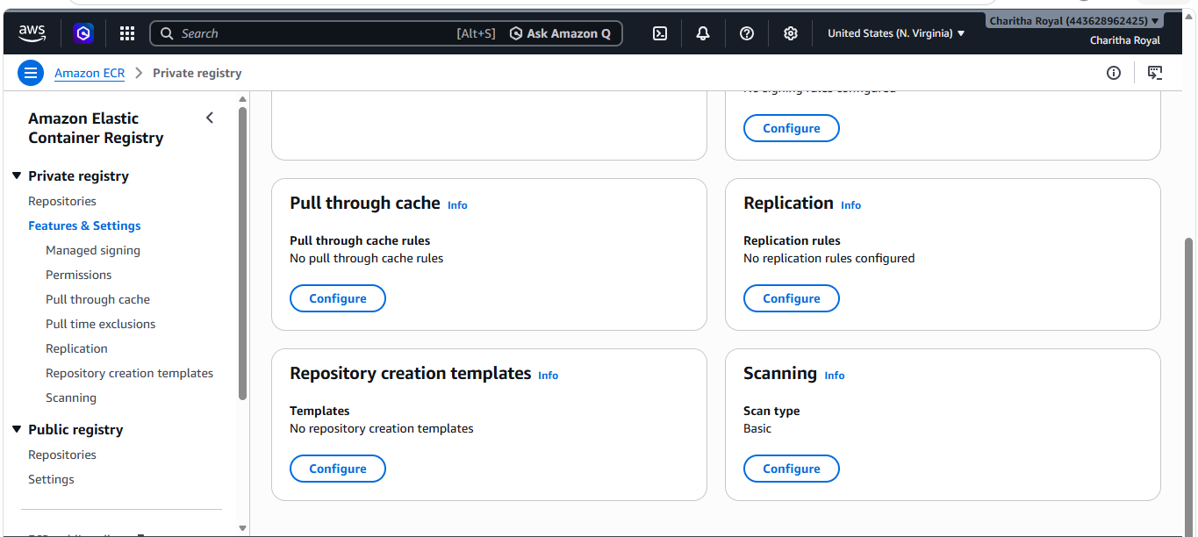
we are turning on the scanning
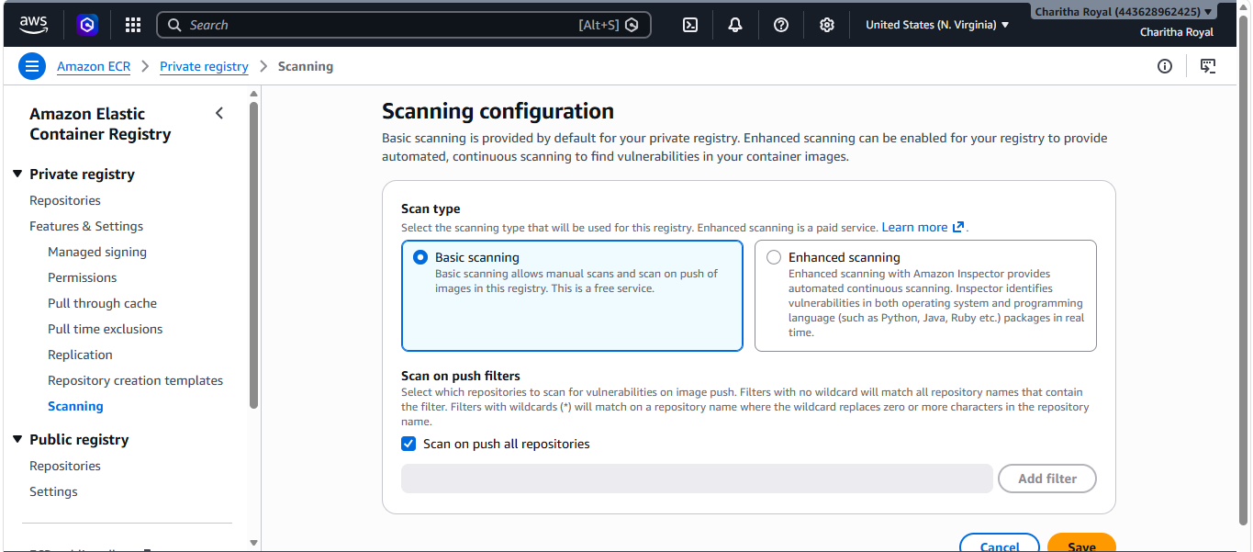
Whenever there is new image push to ecr those will be scanned automatically
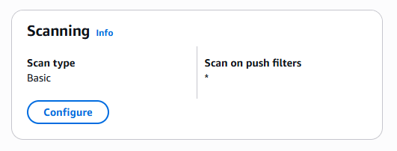
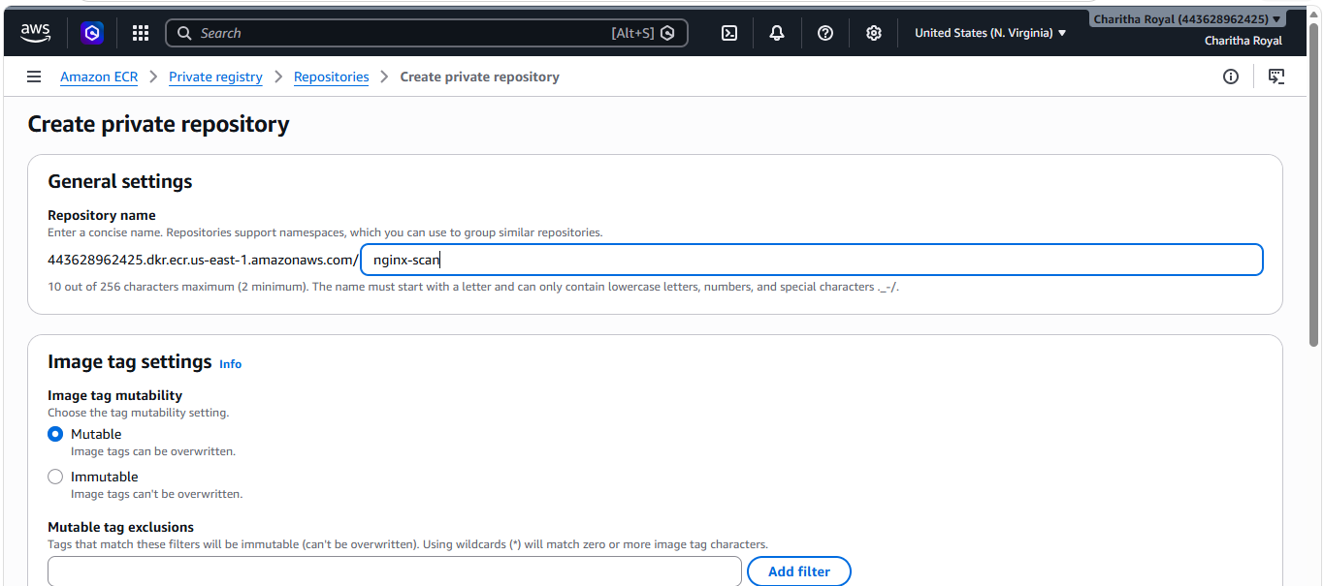
aws ecr get-login-password --region us-east-1 | docker login --username AWS --password-stdin 443628962425.dkr.ecr.us-east-1.amazonaws.com
aws ecr describe-repositories --repository-names nginx-scan --region us-east-1
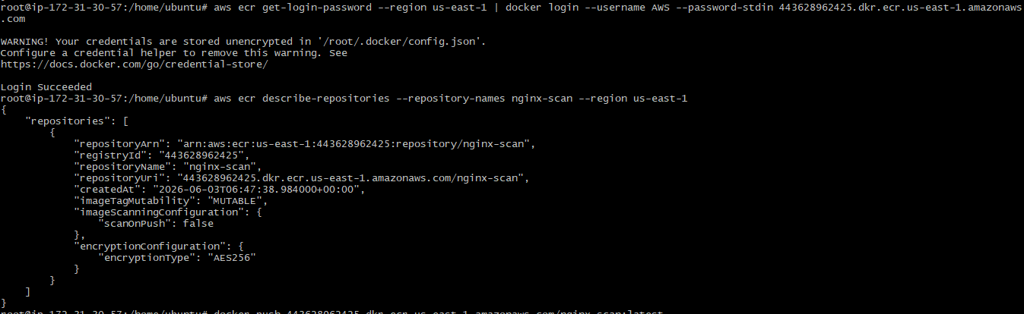
Tagging a image and pushing it to ecr
docker tag nginx-custom:v2
443628962425.dkr.ecr.us-east-1.amazonaws.com/nginx-scan:latest
docker push 443628962425.dkr.ecr.us-east-1.amazonaws.com/nginx-scan:latest
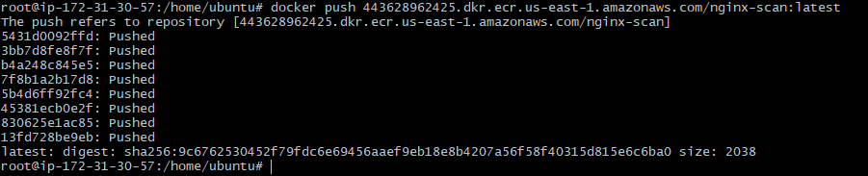
Amazon ECR → Repositories → nginx-scan → Images → latest → Scan Findings

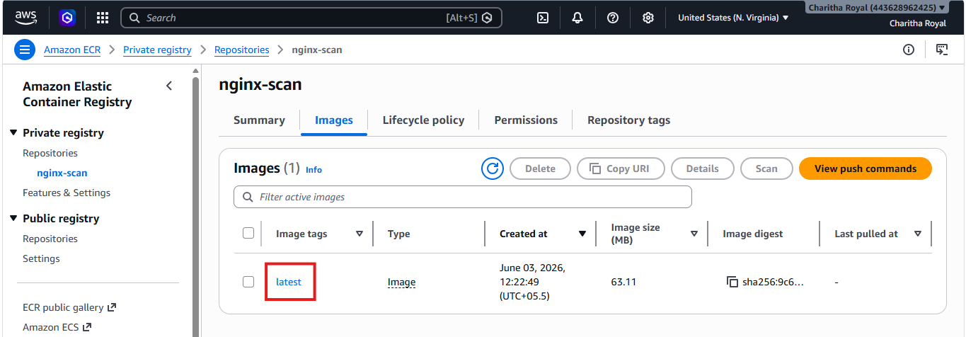
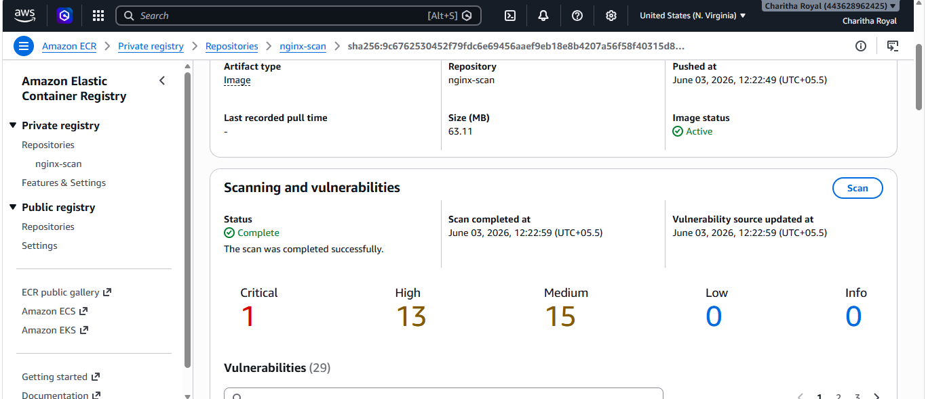
- Create a Jenkins pipeline to create a docker image and push the image to Docker hub.
Start Jenkins Container
docker run -d \
--name jenkins-server \
--restart unless-stopped \
-p 9090:8080 \
-p 50000:50000 \
-v jenkins_home:/var/jenkins_home \
-v /var/run/docker.sock:/var/run/docker.sock \
-u root \
jenkins/jenkins:lts
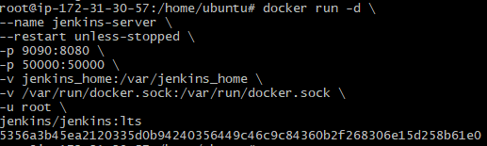
docker start jenkins-server
docker logs jenkins-server
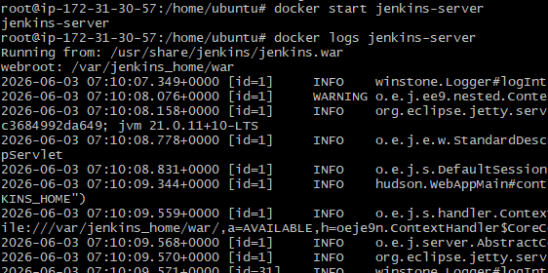
docker exec -it jenkins-server cat /var/jenkins_home/secrets/initialAdminPassword
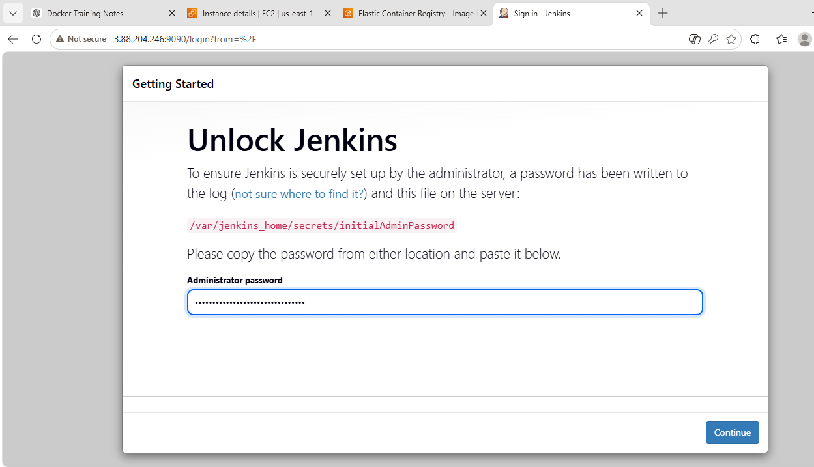
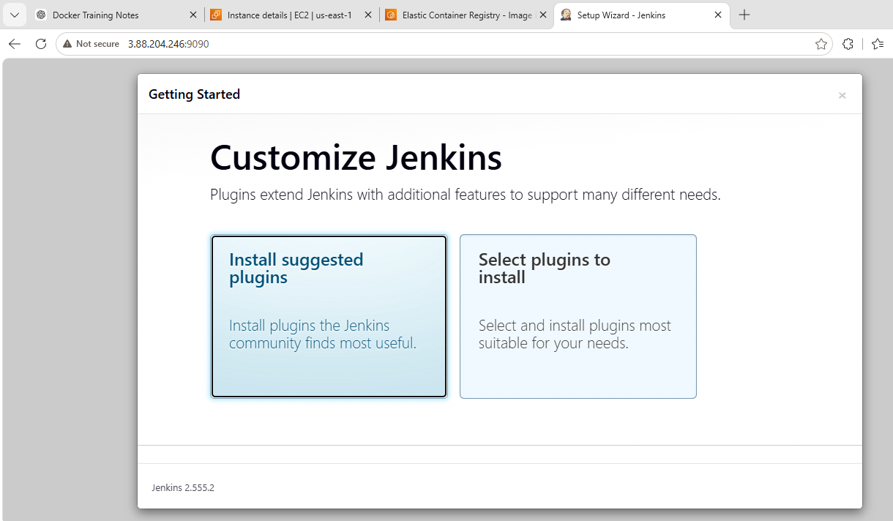
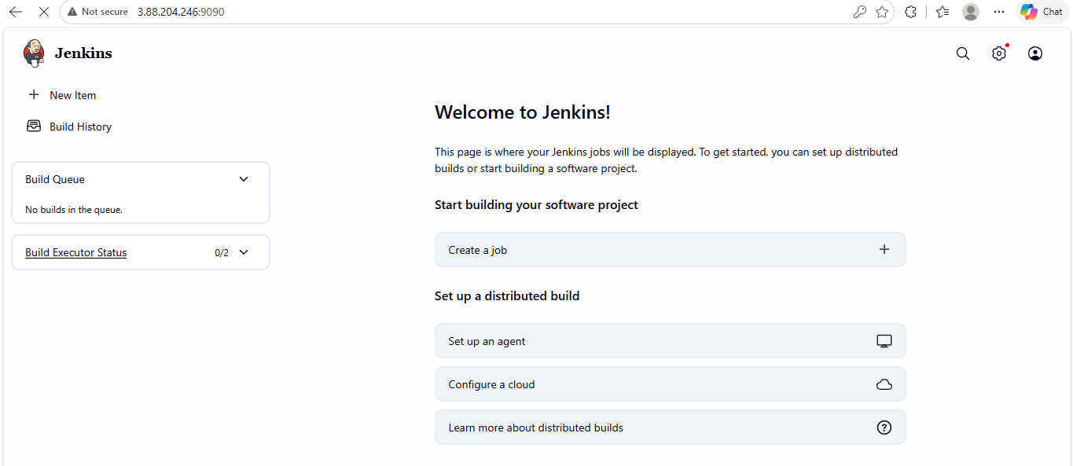
Installing docker plugins
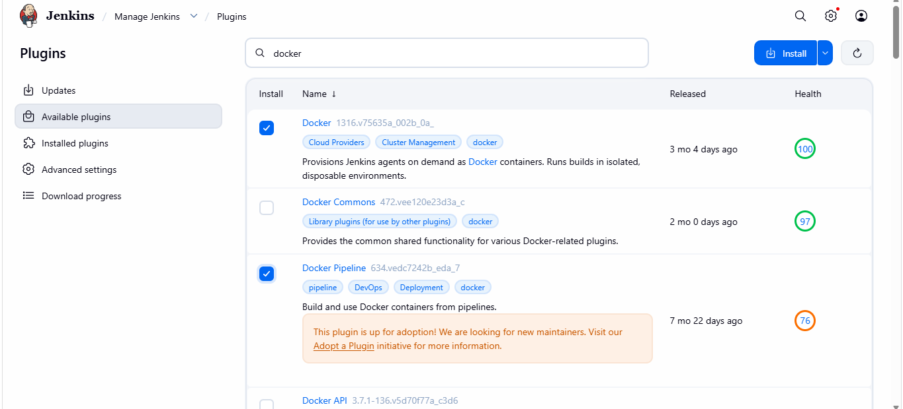
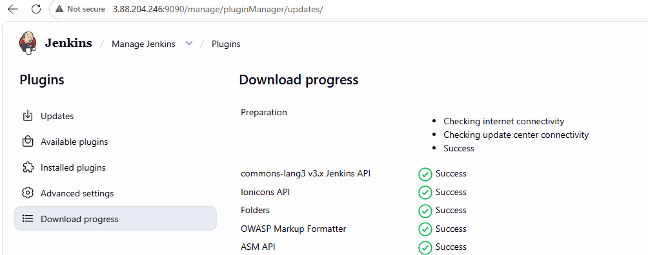
Add Docker Hub Credentials
Manage Jenkins→ Credentials→ System→ Global credentials→ Add Credentials
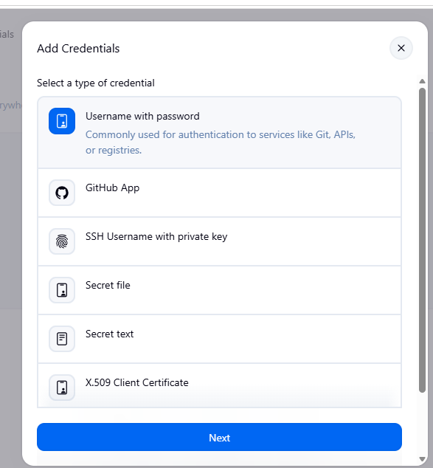
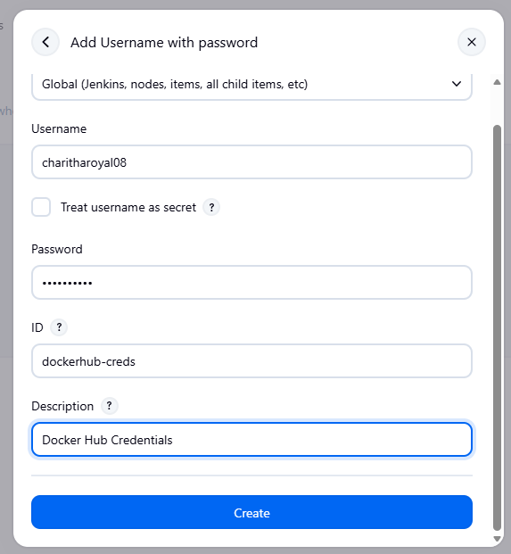
Create Pipeline Job
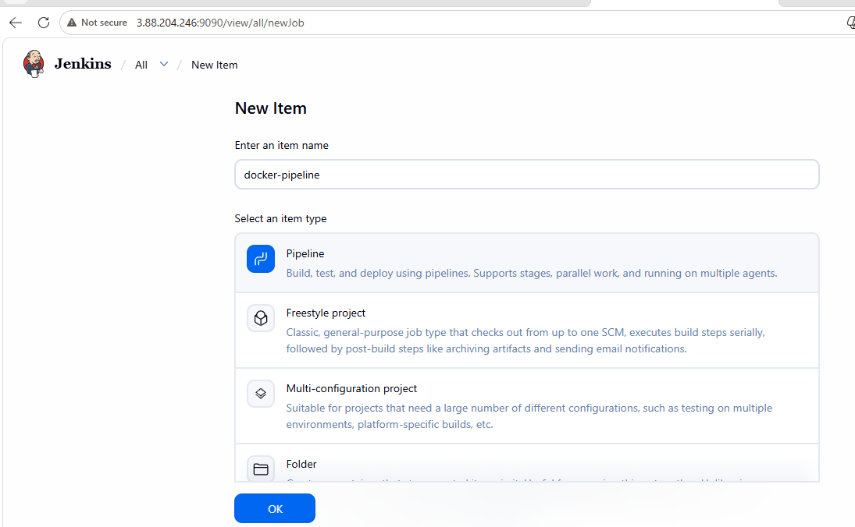
pipeline script
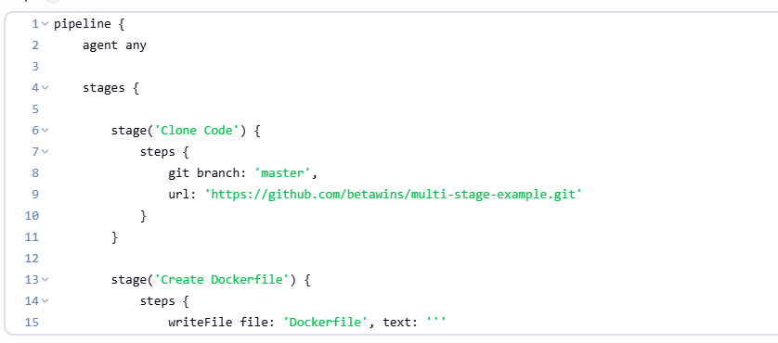
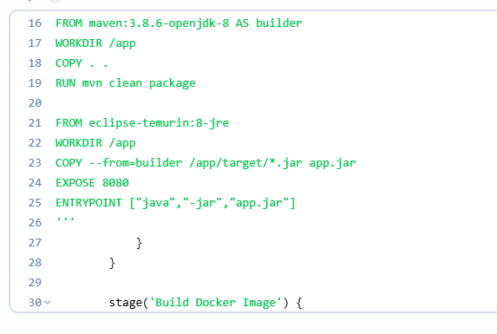
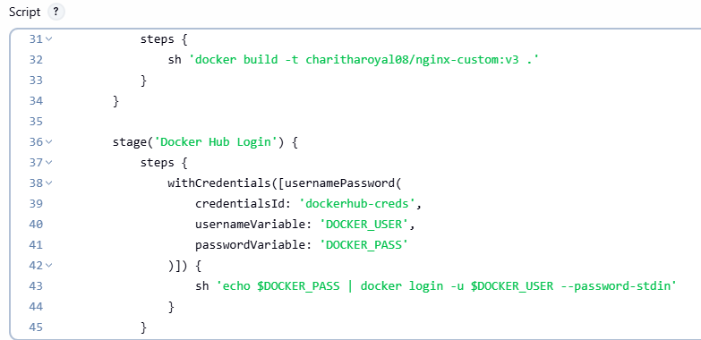
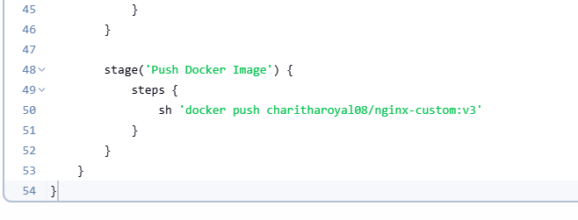
build success
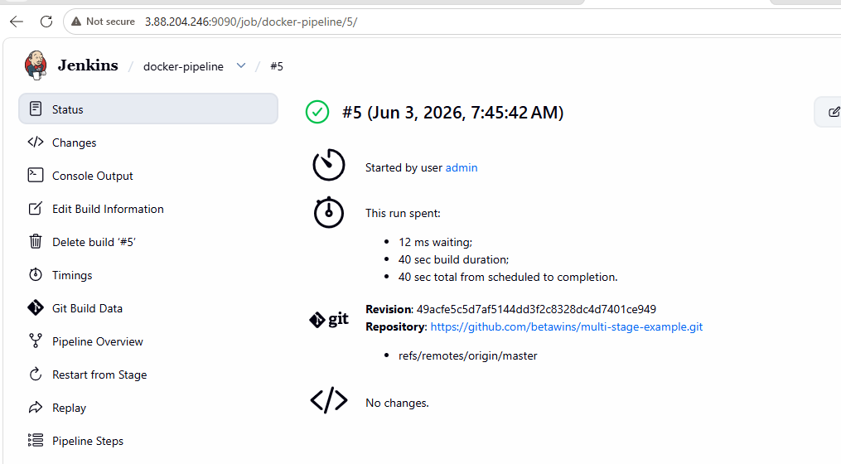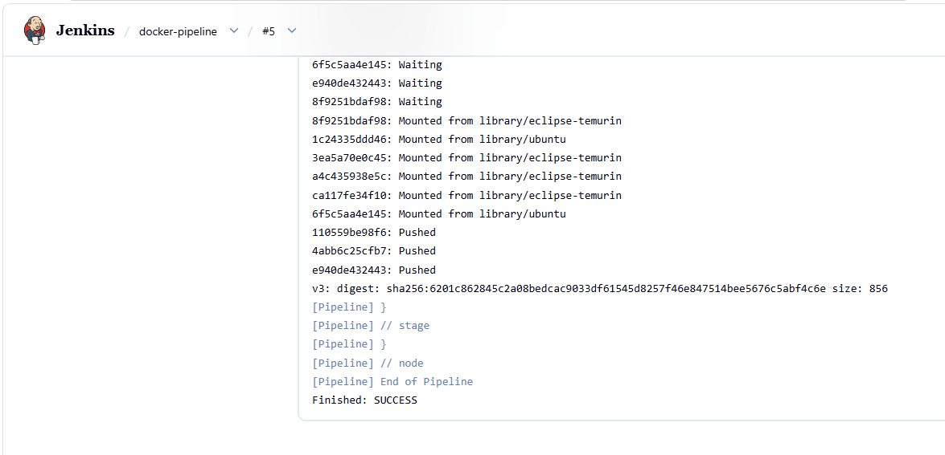
The image has been pushed to docker hub
